

**Project Report**

**1 Certificate o**

**Certificate of Completion**

**The Certificate is presented to;**

**The successfully design & developed on**

**Online Food Ordering System**

**E- Project of ADSE-I (5th Semester)**

**APTECH Worldwide Computer Education Shahrah-e-Faisal Center, Karachi**

**1 Certificate of Completion**

**Table of Contents**

Introduction ……………………………………………………………………………... 02

Proposed Scenario ……………………………………………………………………. 02

System Module …………………………………………………………………………. 03

Functional Requirements …………………………………………………………… 04

**Introduction: –**

**Online Food Ordering System** is a part of e-commerce. E-commerce or business through

Net means distributing, buying, selling, marketing, and servicing of products or services

Over electronic systems such as the Internet and other computer networks. Thus if we

Own a restaurant we need to upload menu online to attract potential customers.

The online food ordering system gives restaurants the ability to increase Sales and

Expand their business by giving customers the facility to order food online.

With an online restaurant menu ordering system, customers can place orders online

24X7. Thus it is a simple, fast and convenient food ordering system giving an edge over

The competition at an affordable price.

**Proposed Solution: –**

Internet has seen a tremendous growth in terms of coverage and awareness. So giving

The business an online presence has become very crucial and important.

With [Online Ordering System], we can set up we restaurant menu online and the

Customers can easily place order with a simple mouse click. Also with a food menu

Online we can easily track the orders, maintain customer&#39; s database and improve the

Food delivery service. We can receive order through e-mails/ fax or directly view on

Internet.

The restaurants’ can even customize online restaurant menu and upload images easily.

Having restaurant menu on internet, potential customers can easily access it and place

Order at their convenience

An online food ordering system is a web-based application that stimulates the foodies

(Customers) to put food orders through internet by locating their favorite restaurant or

Nearest one. This application is based on the asp.net platform.

The main objective of this project is to develop an application which gives provision to

The restaurant owners to flourish their business by uploading menus at no cost and will

Invariably lead to higher customer retention and acquisition rates.

**System Modules:**

**Customer**

1. **Registration:** One time Registration is required.

2. **Login:** After registration, the user can log in and access various features.

3. **Search:** In this section, users can search for hotels and dishes etc.

4. Filter on Food-Type should be allowed at customer level for ease of selection of

Food items.

5. **Online Ordering:** User can select dishes and create &amp; book order

6. **Change Password:** In this section, user can change their own password.

**Restaurant Owner**

1. **Registration:** One time Registration is required.

2. **Login:** After registration, the user can log in and access various features.

3. **Dishes:** In this section, user can add various dishes offered at their restaurant

Along with the price, picture and description.

4. **Food-Type:** User can only select the type of food (Veg/Non-Veg etc.) for every

Food Item as defined by ADMIN.

5. **Upload:** In this section, users can upload the menu card pictures on the website.

6. **Online Reading:** User should be able to read the books online.

7. **Orders:** User can check for all the orders of the day. It should have option to

Filter on Status (Pending and Delivered etc.).

8. **Videos:** In this section, the user can add and edit videos.

9. **Change Password:** In this section, user can change their own password.

**Admin**

1. **Dashboard:** In this section, Admin can see the overview of books available, users

Registered, and categories.

2. **Categories:** In this section, the admin can add, and delete the categories.

3. **Food-Type:** In this section, the admin can add, or delete the food type (Veg/Non-

Veg etc.).

4. **Report:** In this section, Admin can generate report of various hotels and

Customers available.

5. Admin can also update his profile, change the password and recover the

Password

6. Admin can also check for Customer orders and Status.

**Functional Requirements:**

a) Online menus (original and searchable format)

b) Provision of restaurant owners to register themselves with their menu.

c) Easy lookup of restaurants in your area

d) Check Ratings and Review the restaurants

e) Simple, fast and convenient ordering of food

f) Availability of the menu online 24X7X365 – no need to recite the complete menu

Over the phone. An online menu is ready to be viewed and printed by people.

G) Accurate – no more spelling out the dishes’ names.

h) Menu with the actual pictures of the product thereby adding to the uniqueness

Of your online presence.

I) Prior knowledge of time for delivery helps prepare and provide better service.

j) Provides base for online promotions, electronic coupons and gift certificates

Without needing the costly conventional media.

k) Receive direct customer feedback and suggestions.

l) Keep the customers informed.

**Hardware/ Software Requirements**

**Hardware**

1. A minimum computer system that will help you access all the tools in the

Courses is a Pentium 166 or better

2. 128 Megabytes of RAM or better

Operating System

3. Windows 2000 Server (or higher if possible)

Software

4. Windows OS /Python/R/JAVA/Notepad

Source Code: ­­­­

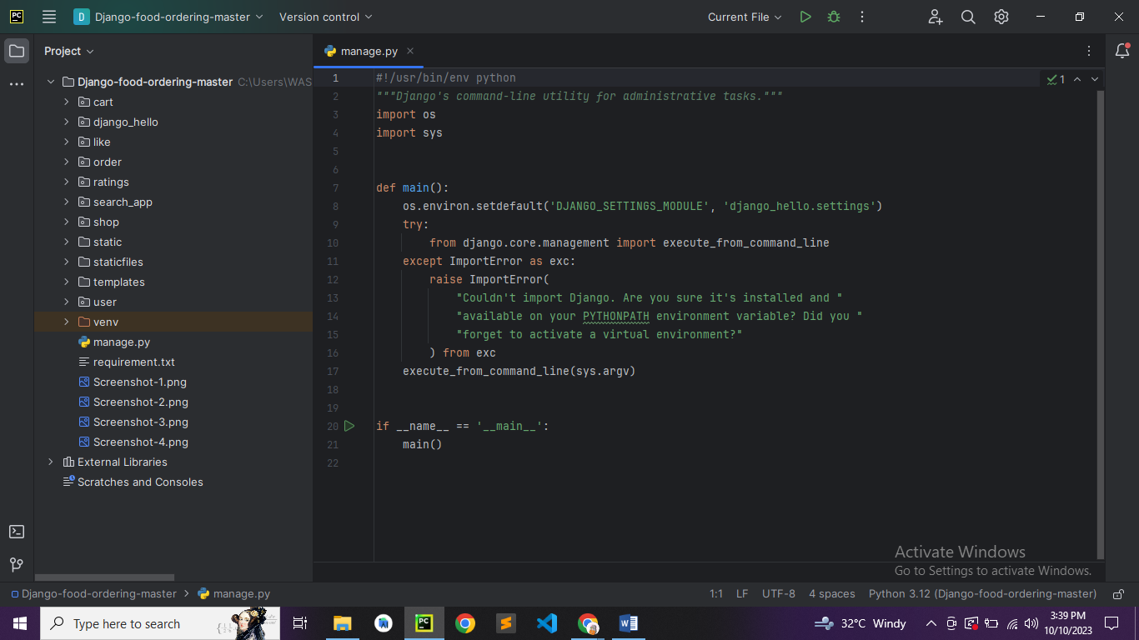

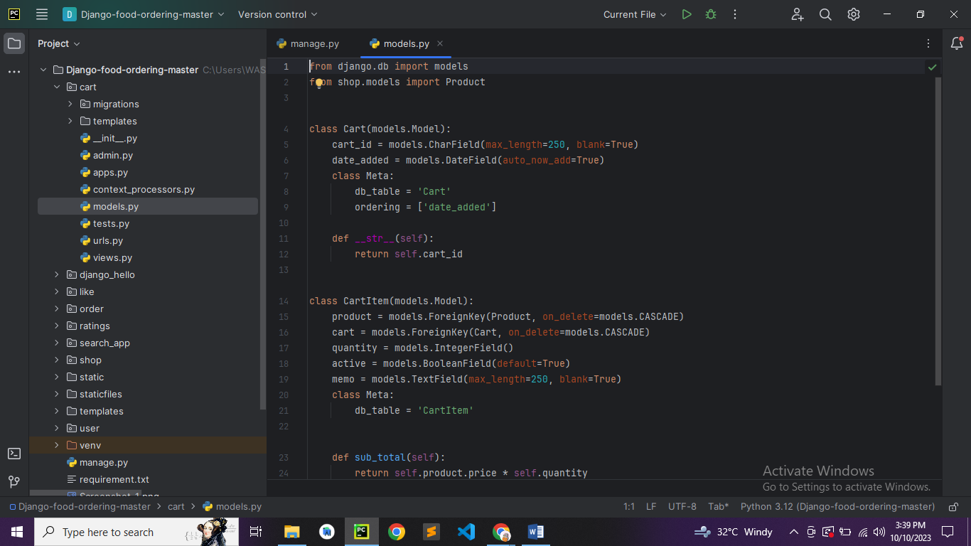

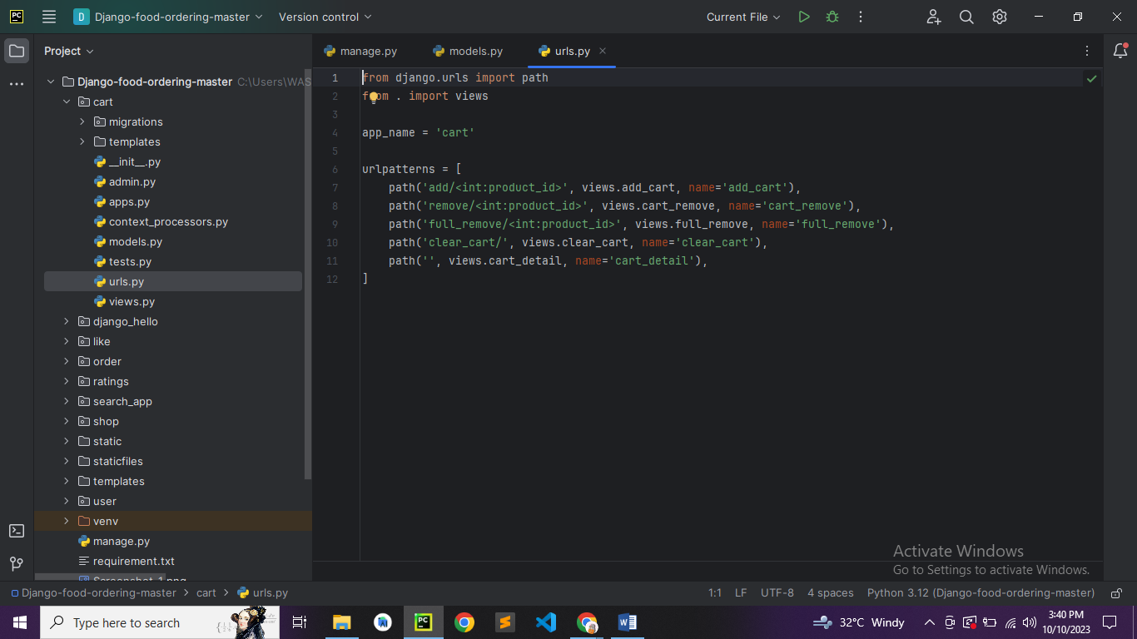

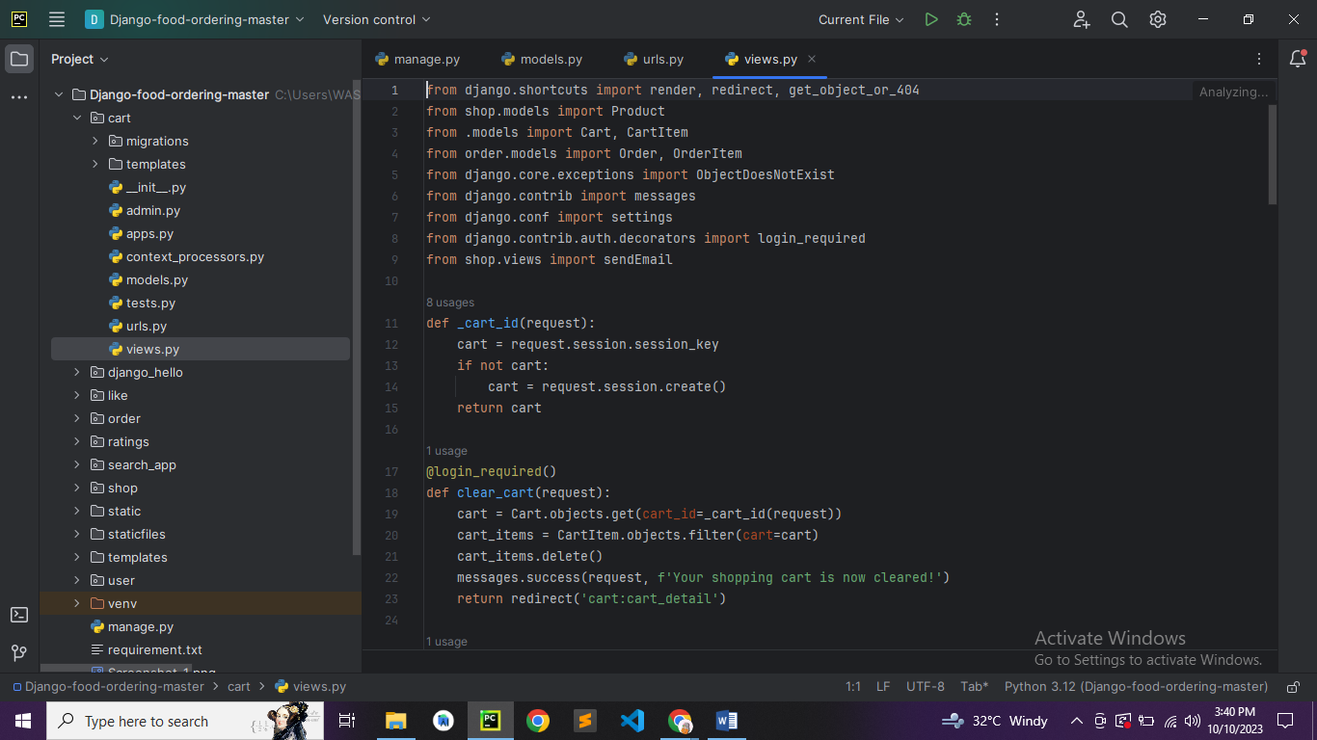

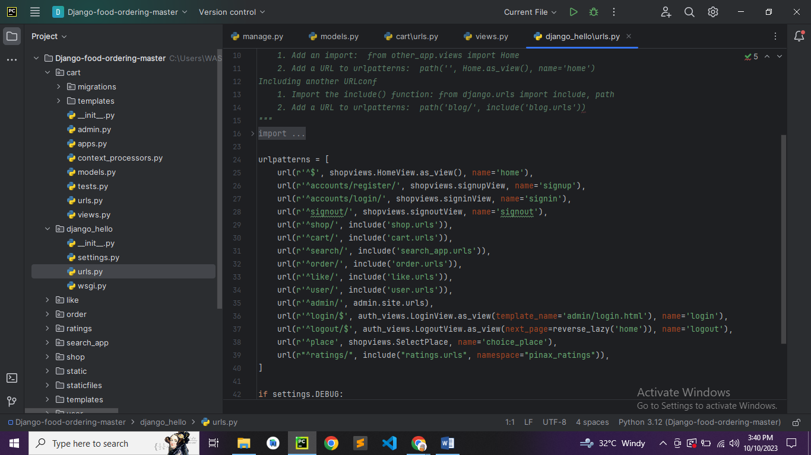

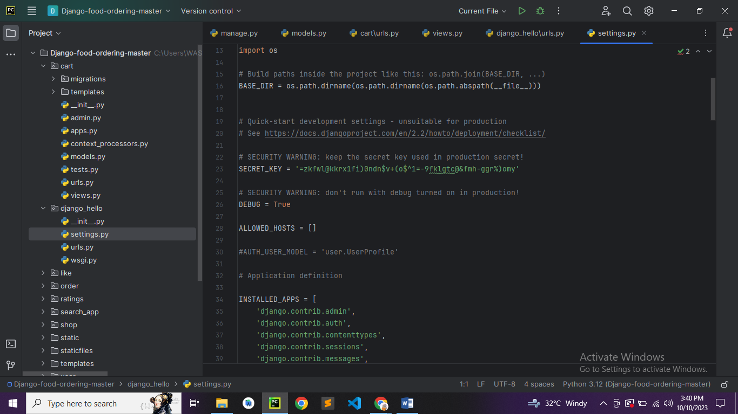

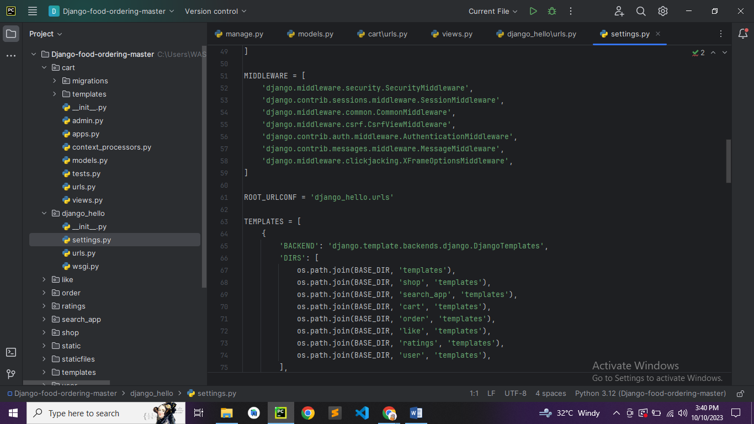

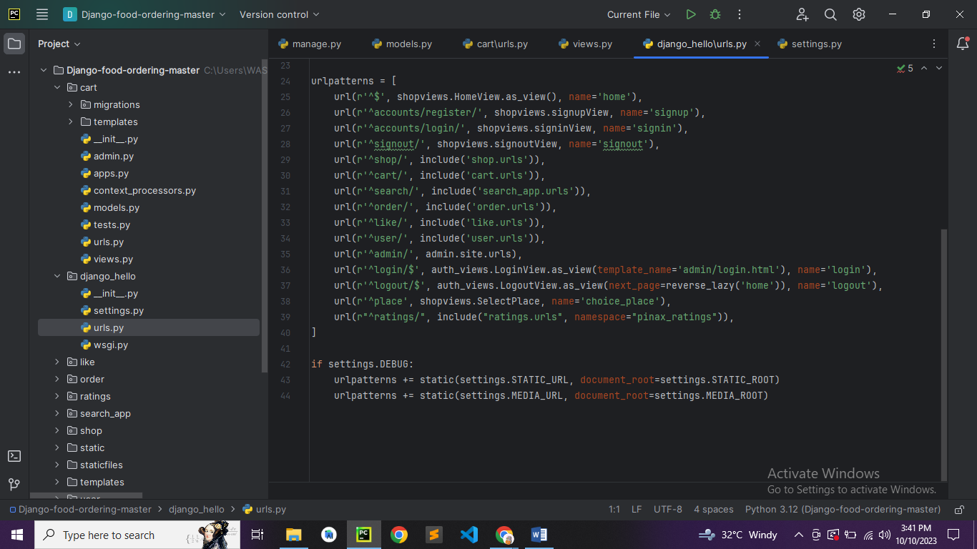

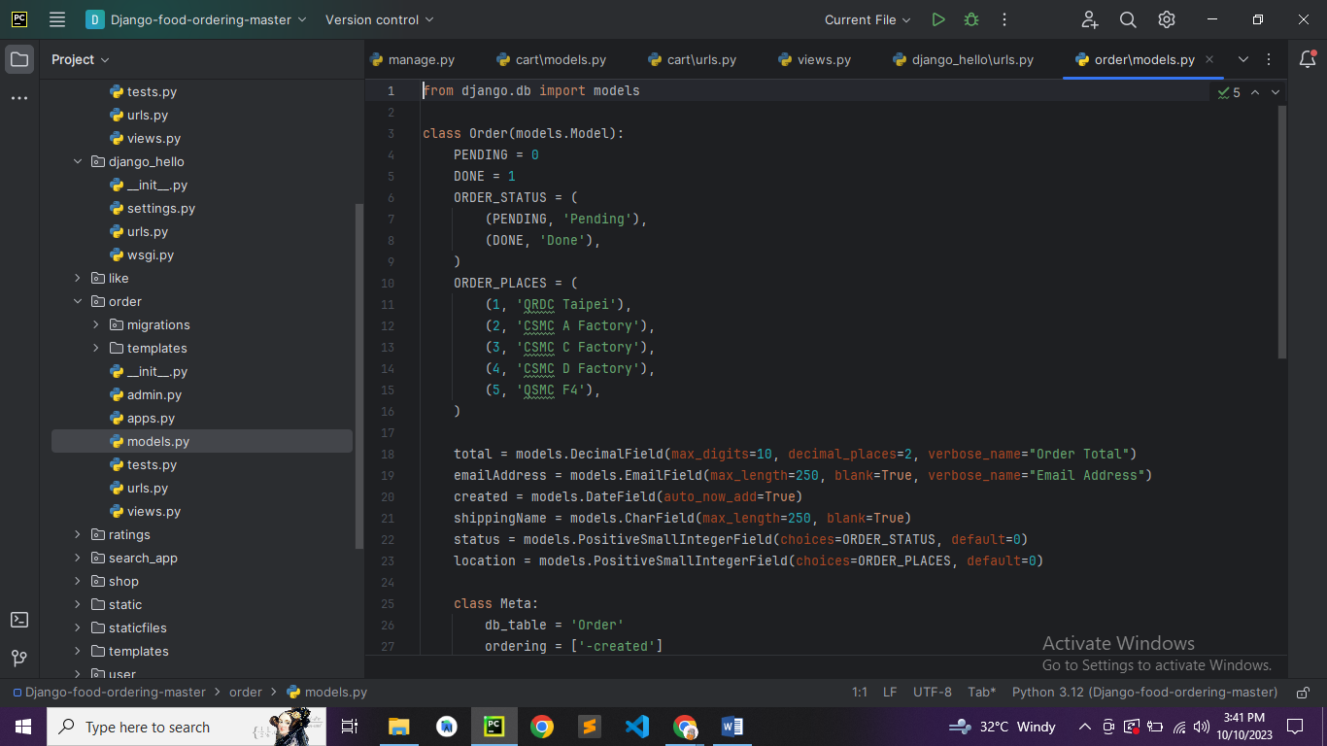

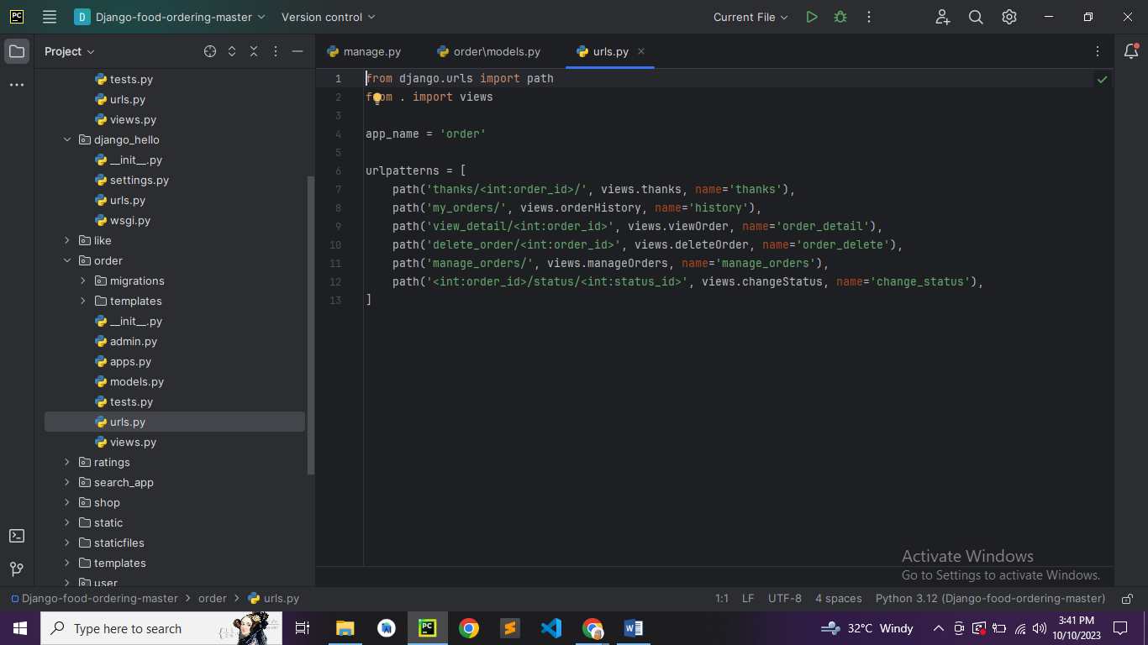

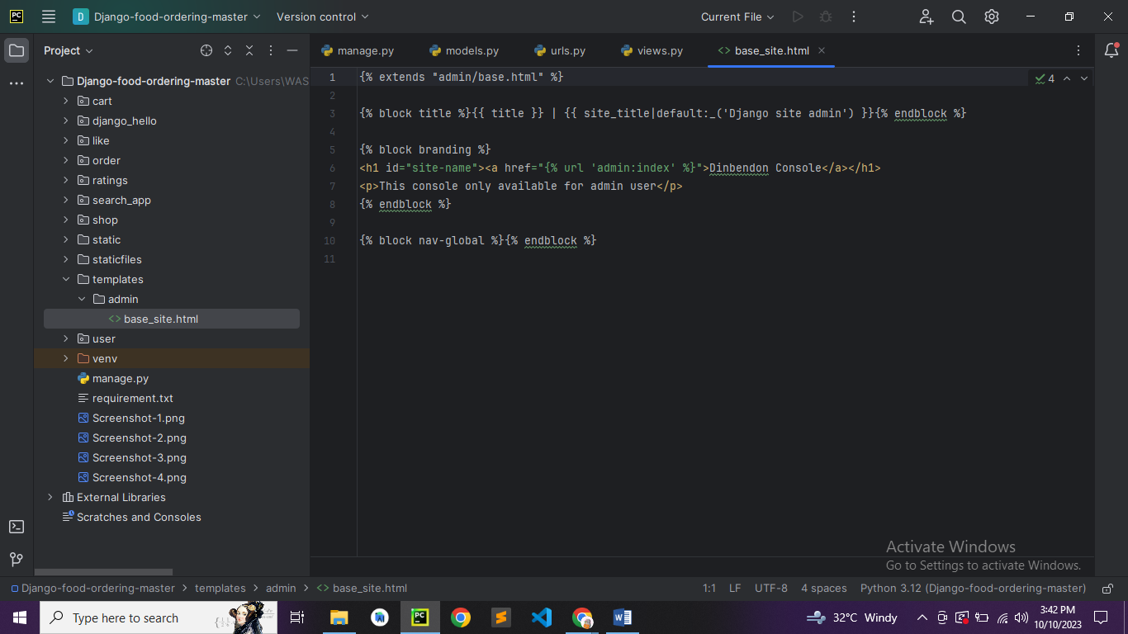

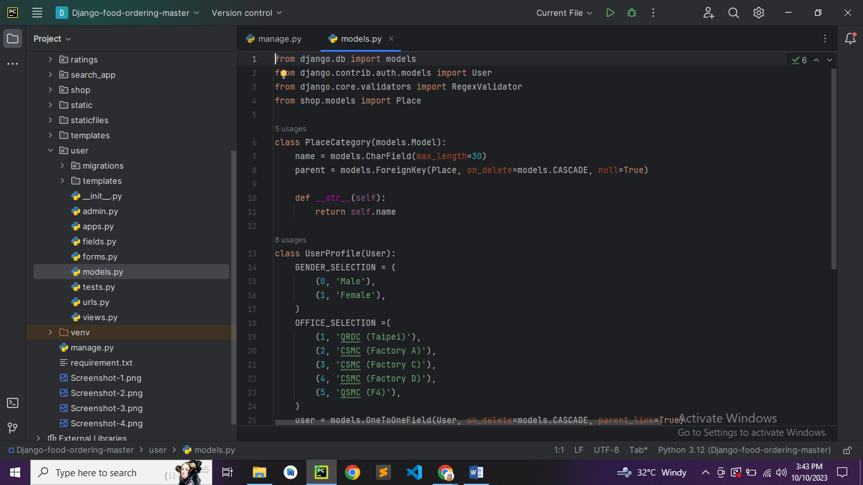

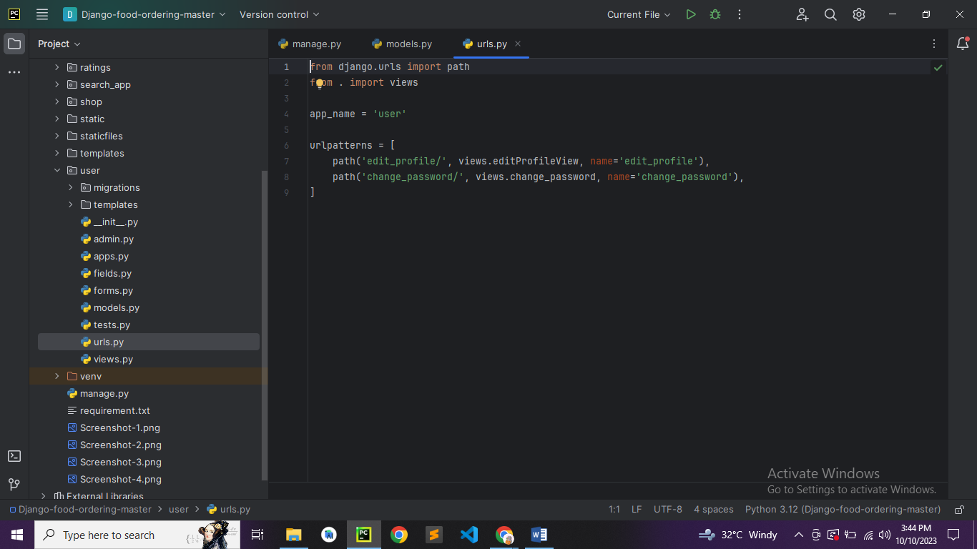

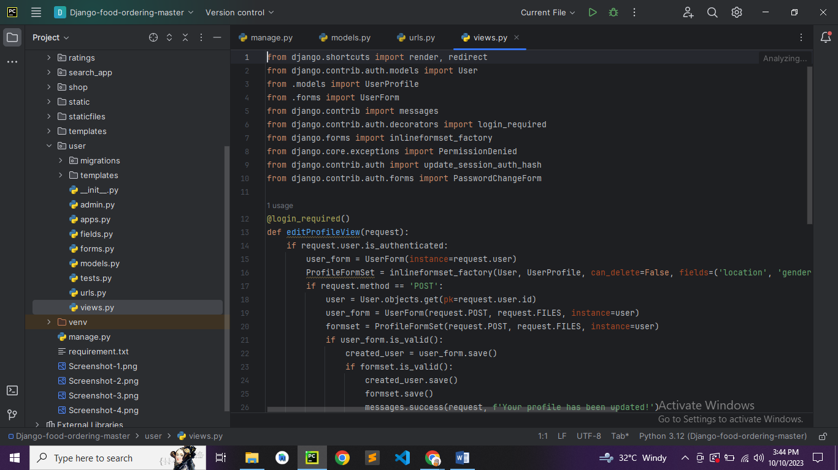

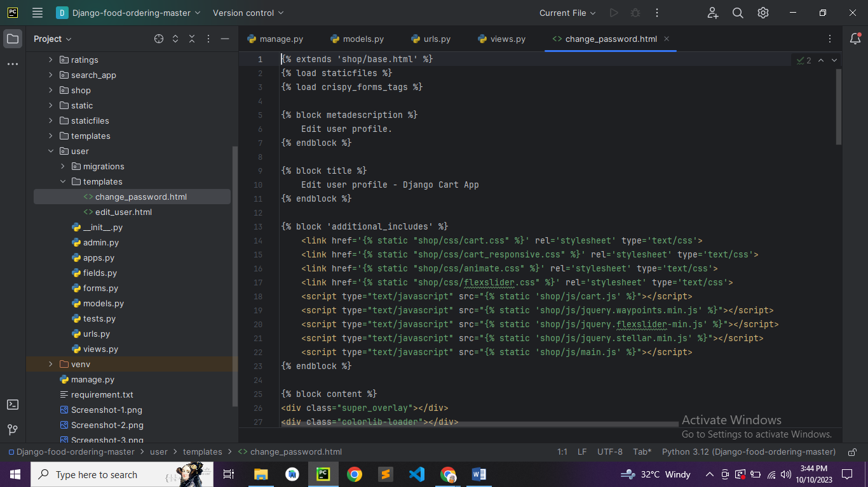

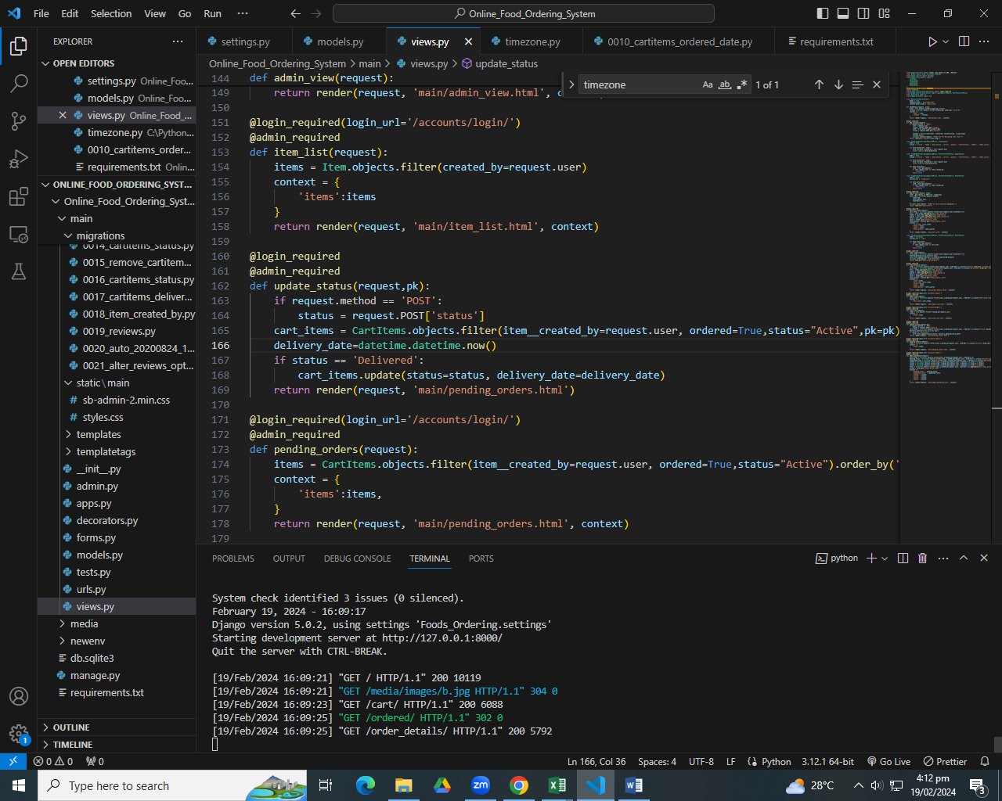

**Website ScreenShot:**

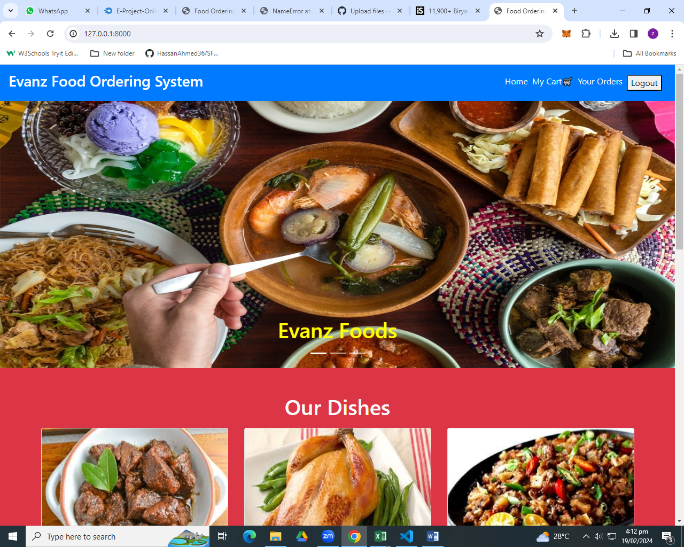

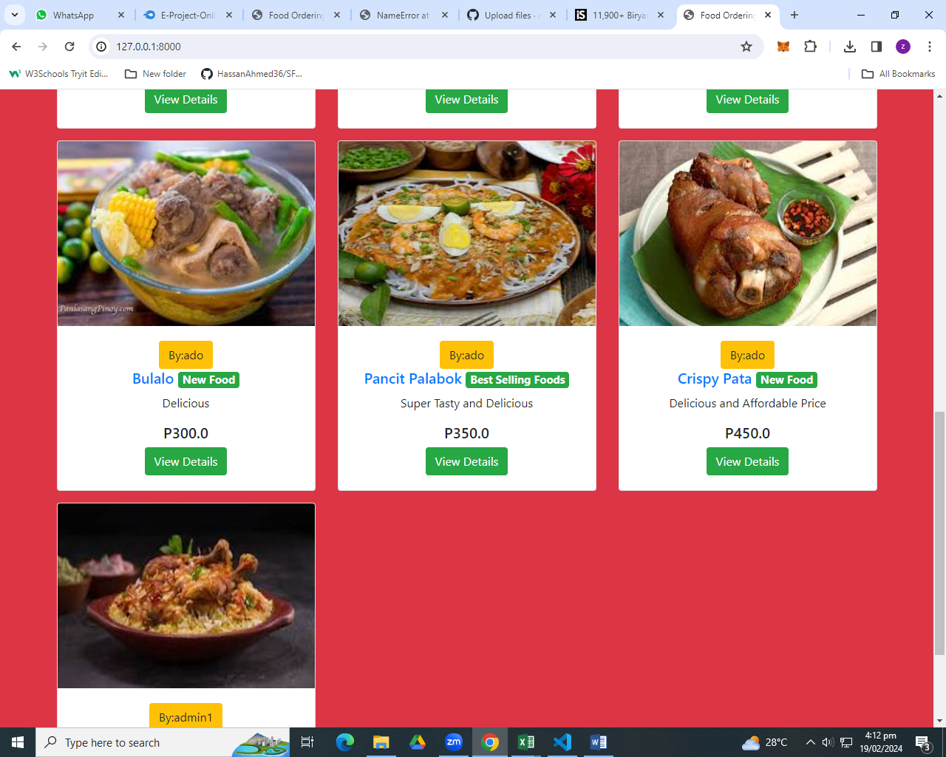

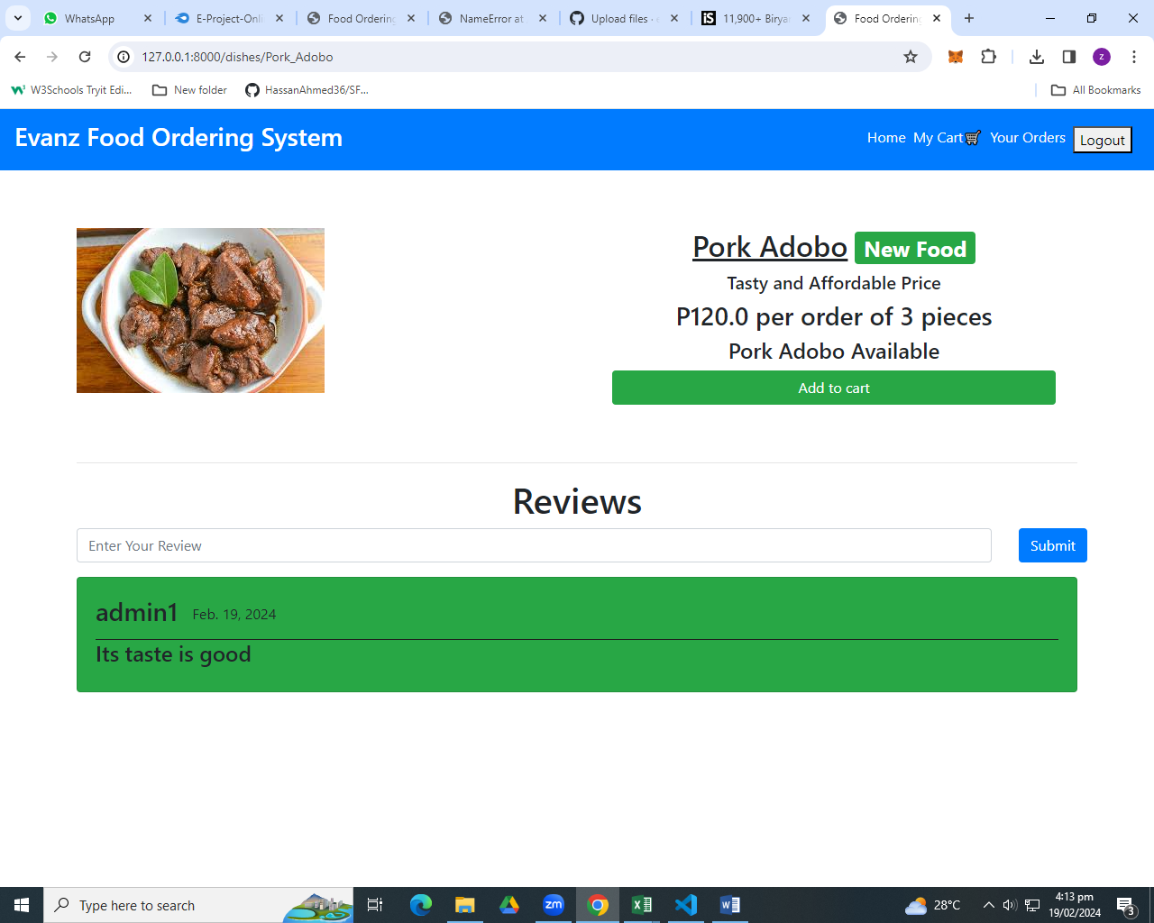

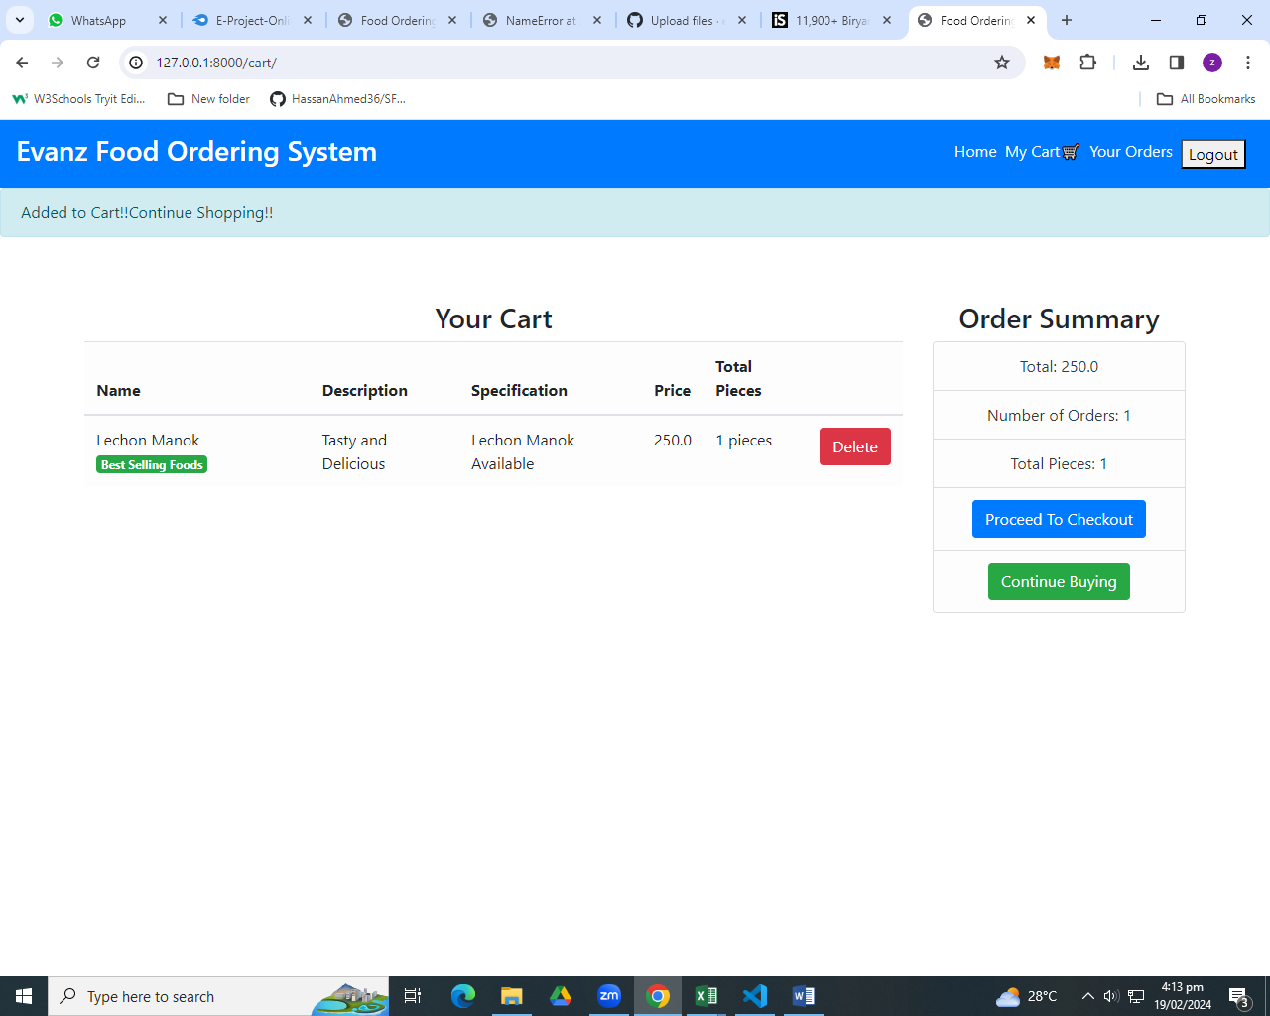

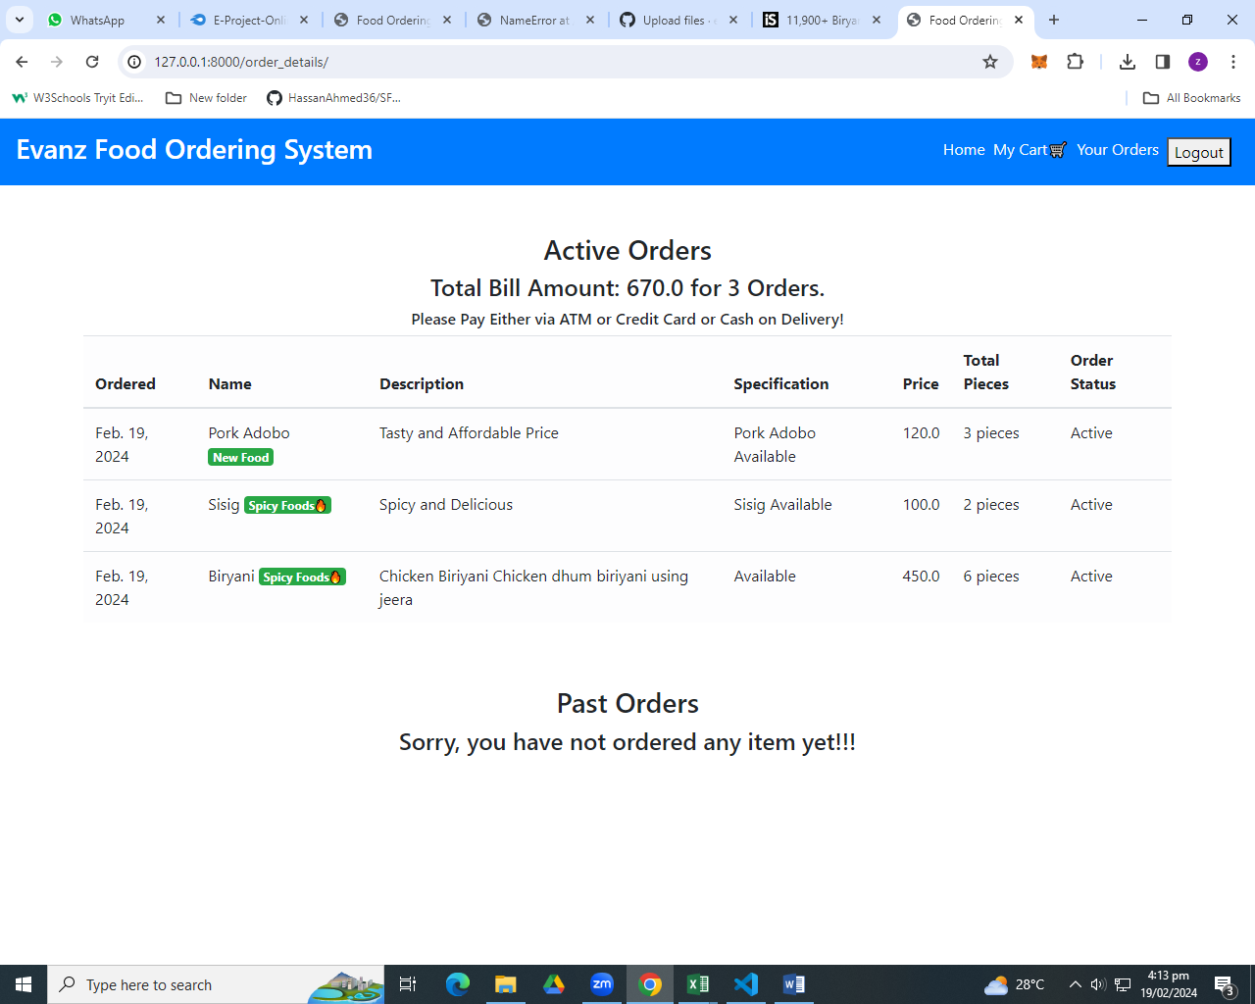

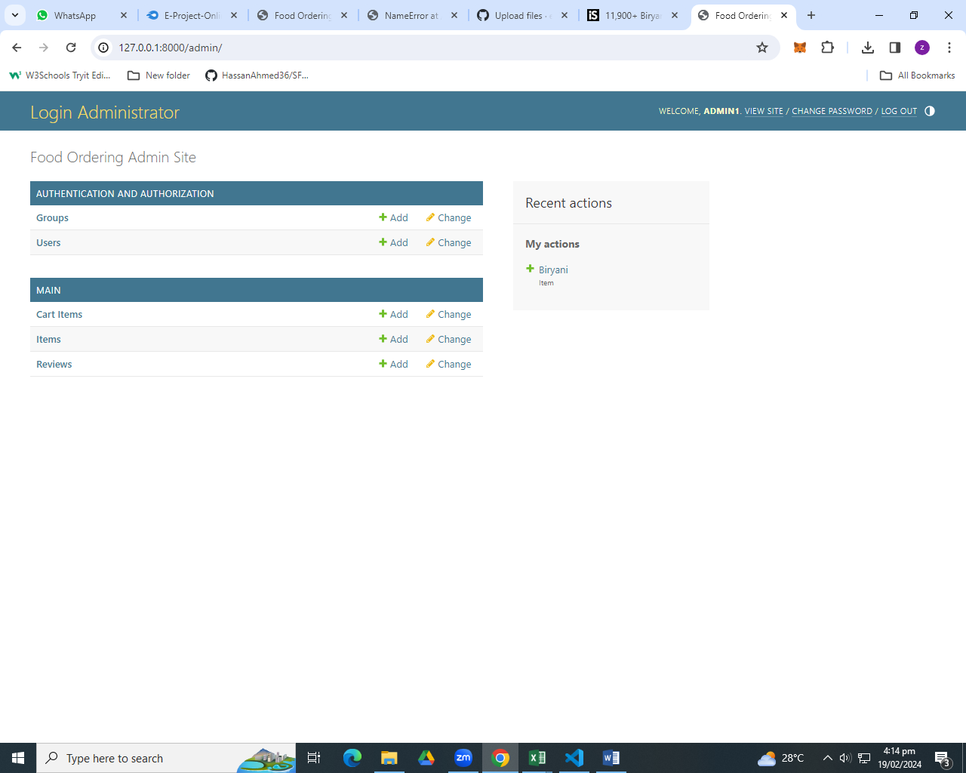

Thank You

In the fruition of this project I would like to thanks. Our teacher Miss Zeenat for his fabulous teaching skills. For his great leadership and vision steered this project from the very first day. And I would like to appreciate my team members for their devotion toward our project. It was a pleasure for all of my team members to word under the supervision of great a great instructor Miss Zeenat. I would like to thanks all of my team members for their work hard And I hope that we will work together again soon.

